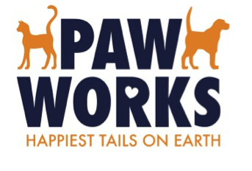

FACT SHEET

Paw Works is a nonprofit animal rescue dedicated to partnering with county and city shelters to give abandoned animals a second chance at life. In just three years, Paw Works has saved more than 3,000 abandoned dogs and cats in Southern California and placed them in caring homes.

Our ultimate goal is to address animal overpopulation and abandonment through adoption, education, awareness and community-driven programs that offer spaying and neutering, training and veterinary care in underserved areas.

As a 501(c)(3) charitable organization, Paw Works relies exclusively on private donations and fundraising to fulfill its mission.

About Paw Works:
- Launched in January 2014
- Helped Ventura County achieve No Kill status within the first month of operation
- Has rescued more than 3,000 abandoned pets to date
- Achieved a 97.5% live release rate last year
- Provides free spaying, neutering, vaccinations and microchipping to hundreds of homeless pets

Our Adoption Centers & Boutiques:
Paw Works has pet adoption centers in Thousand Oaks and Ventura that allow us to introduce rescued animals to potential adoptive families in a calm and comfortable setting. Our Ventura adoption center also includes an upscale resale boutique that sells donated clothing and household items, with proceeds benefitting the nonprofit animal rescue.

Our Goals:
Mobile Spay and Neuter Van
Our efforts to combat pet overpopulation hinge on providing free sterilization, particularly in underserved and
low-income areas. We expect to purchase and fully staff a mobile spay/neuter vehicle to offer spaying, neutering, vaccines and microchipping to the communities that need these services most.

Training Facility and Sanctuary
Paw Works hopes to create a unique boarding/training center and a sanctuary for animals who need special care, including older animals and those with injuries or disabilities. The center will provide the space we need to rescue larger breeds and to address behavioral issues with training and socialization. Providing these services will help abandoned pets become more adoptable to the public and reduce the need for euthanasia in local shelters. And, our rehabilitation and hospice sanctuary will give animals with medical issues or in the final stages of life the home atmosphere they need and deserve.

Our “Pawcratic Oath”
We Shall Lead, Protect, Heal, Comfort and Shelter Those Who Cannot Speak for Themselves.

Paw Works Tax ID #46-4484336

